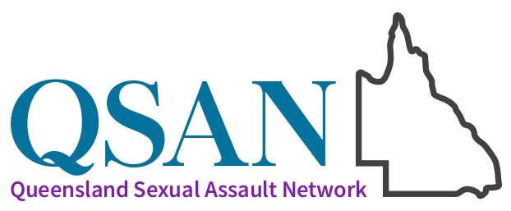

Sexual Violence Awareness Month 2025: “Together, We Can”

Week One
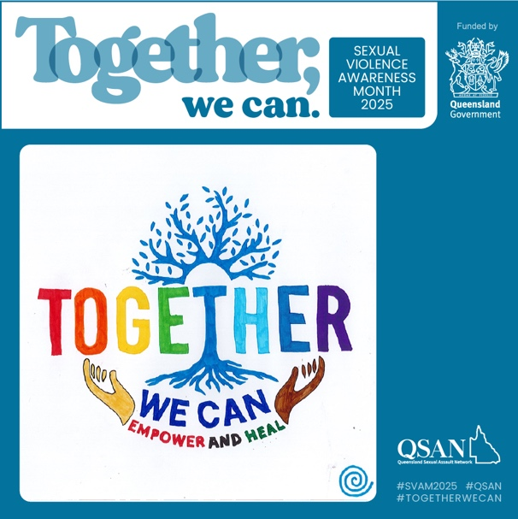
© Copyright retained by the artist.
Alternative text: Outstretched hands below a tree with multi-coloured words together we can empower and heal
Accompanying text:
TOGETHER, WE CAN CHANGE
October is Sexual Violence Awareness Month in Queensland. This year’s theme, Together, We Can calls on all of us to take collective action.
This week, our focus is the sub-theme “Together, we can change”. Harmful attitudes, community norms and victim-blaming attitudes allow sexual violence to take place. Challenging culture is everyone’s responsibility, and every action counts in building safer, more respectful communities—no matter how big or small.
If you wish to talk to someone about issues of sexual violence, please contact the national sexual violence helpline 1800 Respect 1800 737 732 (24/7) or contact a QSAN service at https://qsan.org.au/services/.
In an emergency, phone the police on Triple Zero (000).
© Copyright retained by the artist.
This project is funded by the Queensland Government.
#SVAM2025 #TogetherWeCan #ChallengingCulture #SexualViolencePrevention #SupportSurvivors #NoMore #StopSexualViolence

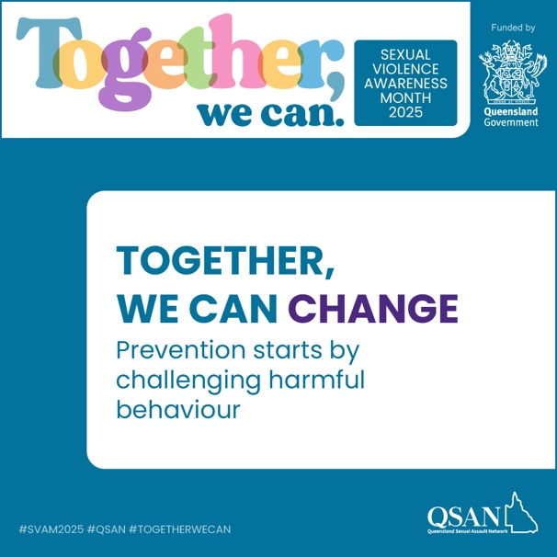
Tile 1
Alternative text: Text reads: Together, we can change. Prevention starts by challenging harmful behaviour
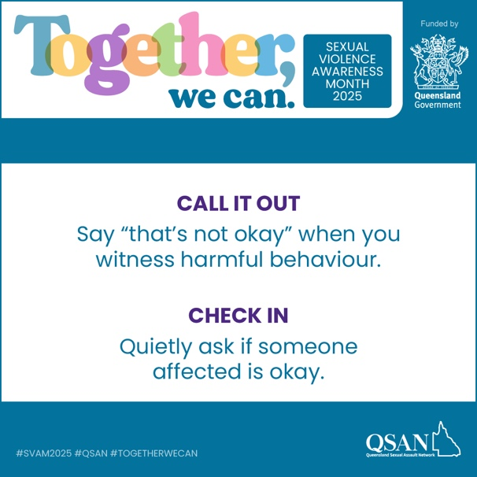
Tile 2
Alternative text: Text reads: Call it out. Say that’s not okay when you witness harmful behaviour. Check in. Quietly ask if someone affected is okay.
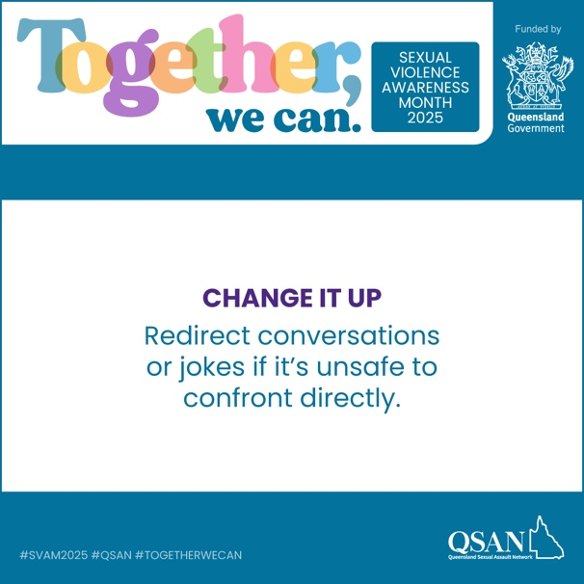
Tile 3
Alternative text: Text reads: Change it up. Redirect conversations or jokes if it’s unsafe to confront directly.
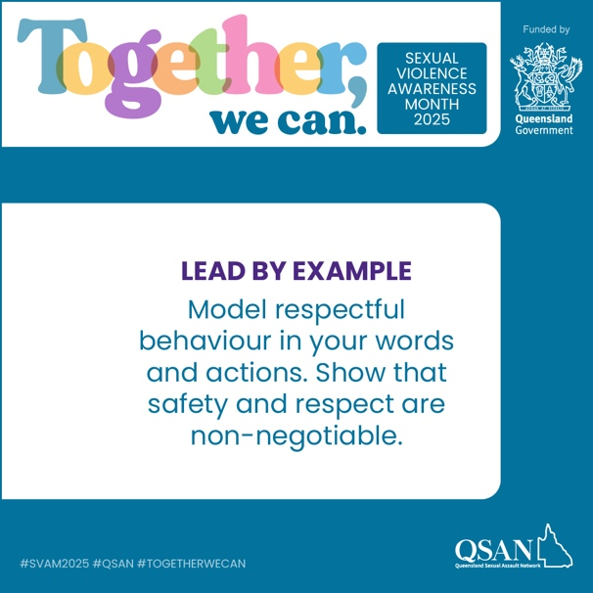
Tile 4
Alternative text: Text reads: Lead by example. Model respectful behaviour in your words and actions. Show that safety and respect are non-negotiable.

Accompanying text:
CHALLENGING HARMFUL BEHAVIOUR
Culture change starts in everyday moments.
Harmful behaviours—like dismissing boundaries, laughing at sexist jokes, or blaming victims—may seem small, but they reinforce toxic culture.
Sexual violence affects people across all communities, but some are at higher risk:
1 in 3 women has experienced physical or sexual violence.
People with disabilities experience higher rates of sexual violence, often from multiple perpetrators.
Gender-diverse people face elevated risk and stigma.
Aboriginal and Torres Strait Islander women statistically experience disproportionally high rates of sexual violence
Simple ways you can make a difference and help prevent sexual violence:
- Call it out: Saying “That’s not okay" can make someone stop and reflect.
- Check in: Ask if the person affected is okay.
- Change it up: Redirect unsafe conversations.
- Lead by example: Model respectful behaviour.
Remember, challenging harmful behaviour isn’t small. It’s how change happens.
If you wish to talk to someone about issues of sexual violence, please contact the national sexual violence helpline 1800 Respect 1800 737 732 (24/7) or contact a QSAN service at https://qsan.org.au/services/.
In an emergency, phone the police on Triple Zero (000).
This project is funded by the Queensland Government.
#SVAM2025 #TogetherWeCan #RisingWithStrength #SurvivorVoices #SexualViolencePrevention #SupportSurvivors #NoMore

Week Two
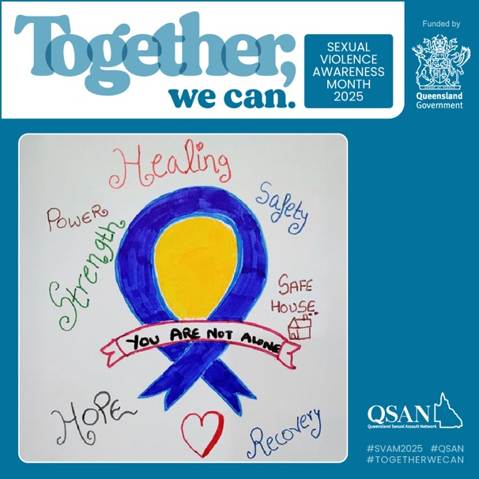
© Copyright retained by the artist.
Alternative text: A blue ribbon around a yellow centre with a banner that says You are not alone, surrounded by words like Healing and Strength, and a heart shape
Accompanying text:
TOGETHER, WE CAN ACT
October is Sexual Violence Awareness Month in Queensland. This year’s theme, Together, We Can calls on communities to act in support of victim-survivors.
This week, our focus is the sub-theme “Together, we can act”. Supporting survivors is critical. Every time we believe and support a survivor, we help break the silence and strengthen the path toward change.
If you wish to talk to someone about issues of sexual violence, please contact the national sexual violence helpline 1800 Respect 1800 737 732 (24/7) or contact a QSAN service at https://qsan.org.au/services/.
In an emergency, phone the police on Triple Zero (000).
© Copyright retained by the artist.
This project is funded by the Queensland Government.
#SVAM2025 #TogetherWeCan #SupportingSurvivors #SexualViolenceAwareness #StopSexualViolence #NoMore #SurvivorVoices

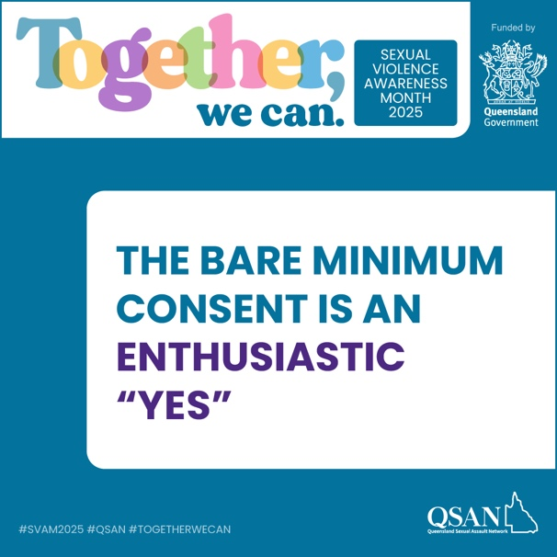
Tile 1
Alternative text: Text reads: Together, we can change. Prevention starts by challenging harmful behaviour
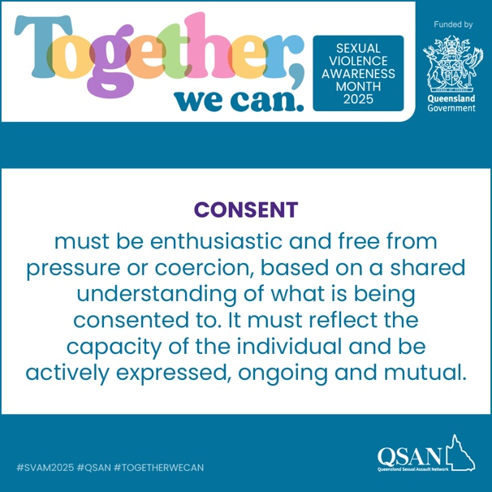
Tile 2
Alternative text: Tile reads: Consent must be enthusiastic and free from pressure or coercion, based on a shared understanding of what is being consented to. It must reflect the capacity of the individual and be actively expressed, ongoing and mutual.
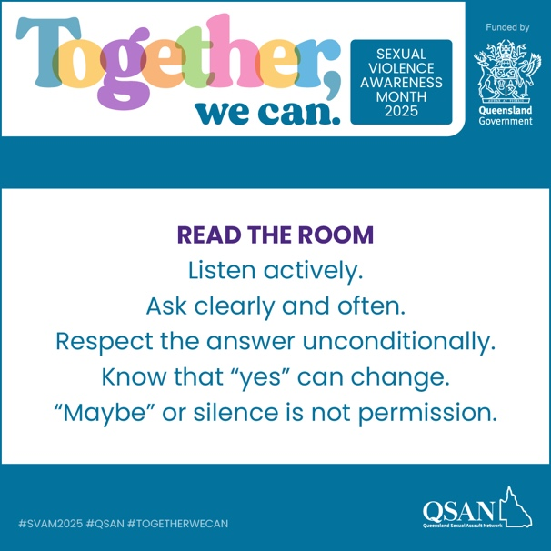
Tile 3
Alternative text: Text reads: Read the room. Listen actively. Ask clearly and often. Respect the answer unconditionally. Know that yes can change. Maybe or silence is not permission.
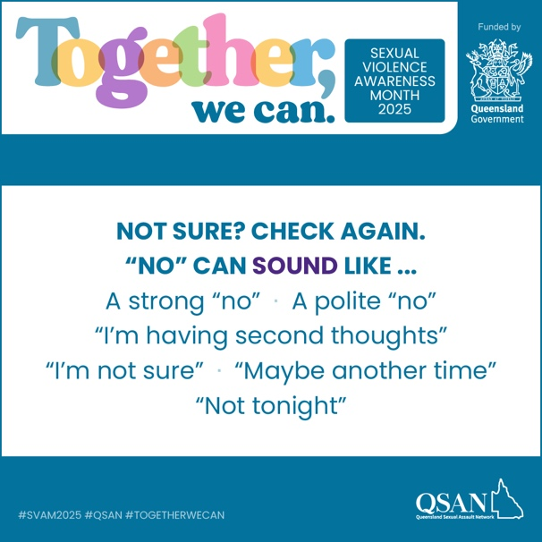
Tile 4
Alternative text: Text reads: Not sure? Check again. No can sound like a strong no, a polite no, I’m having second thoughts, I’m not sure, maybe another time, Not tonight.
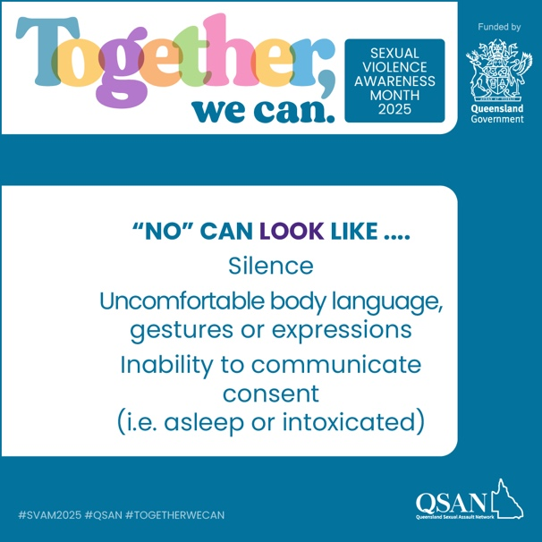
Tile 5
Alternative text: Text reads: No can look like silence, uncomfortable body language, gestures or expressions, inability to communicate consent (i.e. asleep or intoxicated)

Accompanying text:
CONSENT
The way we communicate and practice consent can look different from person to person.
But the basic requirement for consent is the same for everyone: a clear, ongoing and enthusiastic “yes”.
Consent should never be assumed. Not before, not during, and not because of something that happened in the past. Saying “yes” to one thing does not mean agreement for something else or for the future.
Unfortunately, harmful attitudes persist. A 2021 national survey on attitudes to violence against women found that 10% of people believe women often say “no” when they actually mean “yes”. Such is a dangerous misconception that can put people at serious risk.
Remember:
- Consent must be freely given, without pressure or coercion
- It must be informed, with a full understanding of what is being agreed to
- Silence, freezing or lack of resistance is not consent
- Consent can be withdrawn at any time
Affirmative consent is about respect, safety and choice for everyone.
If you wish to talk to someone about issues of sexual violence, please contact the national sexual violence helpline 1800 Respect 1800 737 732 (24/7) or contact a QSAN service at https://qsan.org.au/services/.
In an emergency, phone the police on Triple Zero (000).
This project is funded by the Queensland Government.
#SVAM2025 #TogetherWeCan #RisingWithStrength #SurvivorVoices #SexualViolencePrevention #SupportSurvivors #NoMore

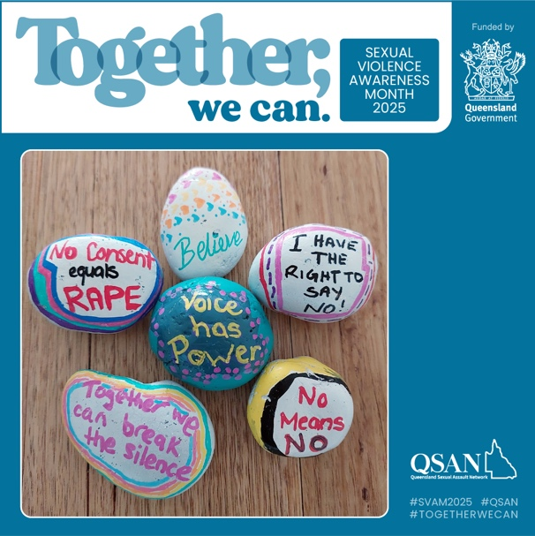
Tile 1
© Copyright retained by the artists.
Alternative text: 6 painted river rocks on a wooden surface, each rock has a different message painted including No consent equals rape, Voice has power, No means no

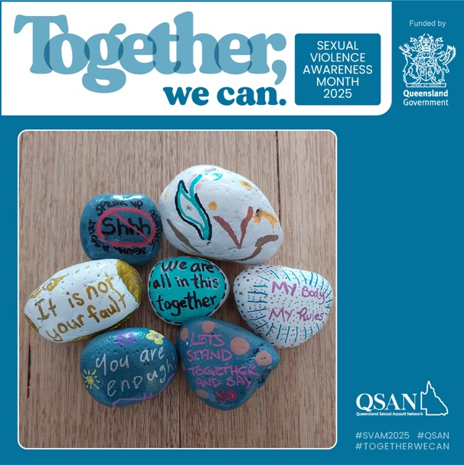
Tile 2
© Copyright retained by the artists.
Alternative text: 7 painted river rocks on a wooden surface, each rock has a different message painted including It is not your fault, We are all in this together, You are enough
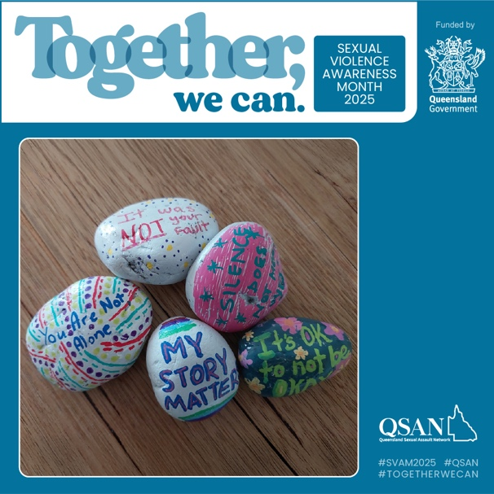
Tile 3
© Copyright retained by the artists.
Alternative text: 5 painted river rocks on a wooden surface, each rock has a different message painted including You are not alone, My story matters, Its okay to not be okay

Accompanying text:
TOGETHER, WE CAN ACT
(as above)

Week Three
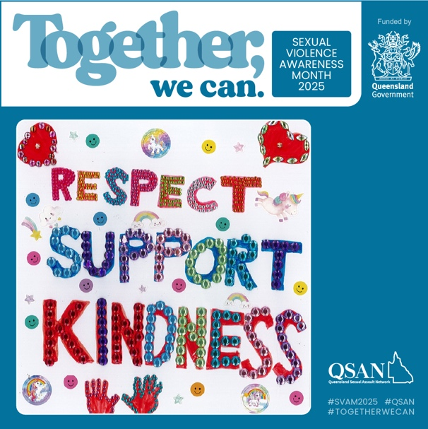
© Copyright retained by the artist.
Alternative text: Bright coloured words Respect Support Kindness made up of sequins and surrounded by colourful stickers including hearts and smiley faces.
Accompanying text:
TOGETHER, WE CAN RISE
October is Sexual Violence Awareness Month in Queensland. This year’s theme, Together, We Can celebrates the resilience and courage of victim-survivors.
This week, our focus is the sub-theme “Together, we can rise”. Victim-survivors show extraordinary courage, resilience, and determination to be heard. But we can and must do better. By amplifying survivor voices and creative work, we honour the courage and determination it takes to overcome trauma and drive change.
If you wish to talk to someone about issues of sexual violence, please contact the national sexual violence helpline 1800 Respect 1800 737 732 (24/7) or contact a QSAN service at https://qsan.org.au/services/.
In an emergency, phone the police on Triple Zero (000).
© Copyright retained by the artist.
This project is funded by the Queensland Government.
#SVAM2025 #TogetherWeCan #RisingWithStrength #SurvivorVoices #SexualViolencePrevention #SupportSurvivors #NoMore

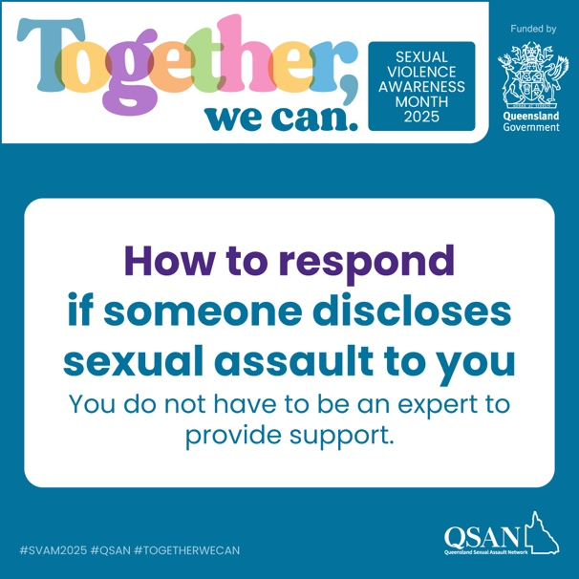
Alternative text: Text reads: How to respond if someone discloses sexual assault to you. You do not have to be an expert to provide support.
Accompanying text:
HOW TO RESPOND IF SOMEONE DISCLOSES SEXUAL ASSAULT TO YOU
If someone discloses sexual assault to you, it's ok to not know how to respond.
You do not need to be an expert to be able to support someone. By being a trusted person and listening, you are already helping.
Here are a few things to keep in mind when providing support:
🩵 LISTEN
Listen with respect and patience; and without judgement, interruption or questions.
🩵 BELIEVE
Trust what they are telling you. help them feel safe and comfortable.
🩵 SUPPORT
Let them to make their own choices about what happens next when they are ready to, but offer practical help and let them know free, confidential and professional help is available.
There are specialist sexual assault and counselling support services throughout Queensland who can help people to heal. If you wish to talk to someone about issues of sexual violence, please, you can find a directory of specialist sexual assault services at the QSAN Services Page here: http://bit.ly/41yv9jS
Alternatively, contact the national sexual violence helpline 1800 Respect 1800 737 732 (24/7).
In an emergency, phone the police on Triple Zero (000).
This project is funded by the Queensland Government.
#SVAM2025 #TogetherWeCan #RisingWithStrength #SurvivorVoices #SexualViolencePrevention #SupportSurvivors #NoMore

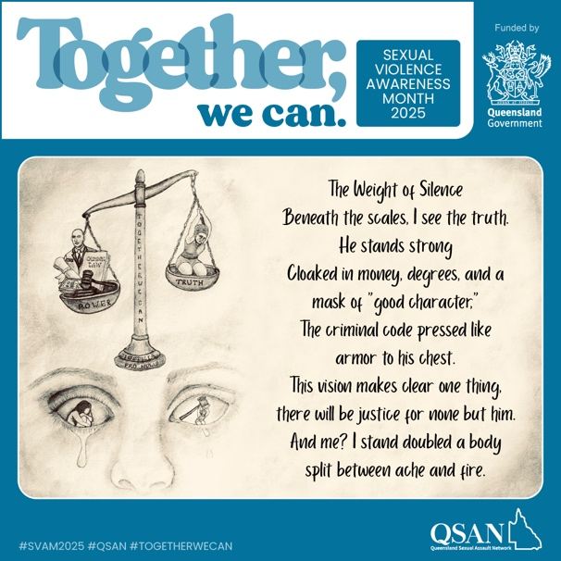
Tile 1
© Copyright retained by the artist.
Alternative text: Hand drawing depicting scales with one side labelled power (legal icons) weighing more heavily than truth (a sad woman with uplifted arms). Below the scales is part of a crying face. To the right is the first part of the accompanying poem.

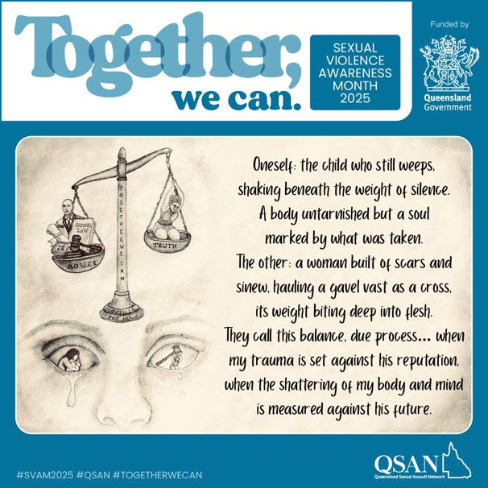
Tile 2
© Copyright retained by the artist.
Alternative text: Hand drawing depicting scales with one side labelled power (legal icons) weighing more heavily than truth (a sad woman with uplifted arms). Below the scales is part of a crying face. To the right is the second part of the accompanying poem.
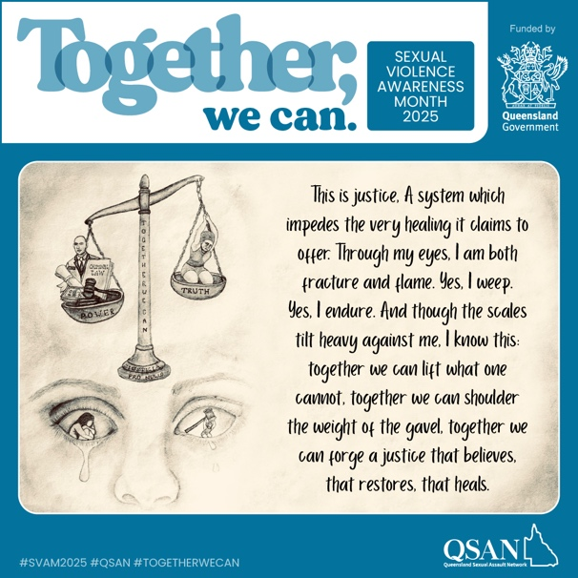
Tile 3
© Copyright retained by the artist.
Alternative text: Hand drawing depicting scales with one side labelled power (legal icons) weighing more heavily than truth (a sad woman with uplifted arms). Below the scales is part of a crying face. To the right is the third part of the accompanying poem.

Accompanying text:
TOGETHER, WE CAN RISE
(as above)
Poem: The Weight of Silence
Beneath the scales, I see the truth. He stands strong cloaked in money, degrees, and a mask of “good character,” the criminal code pressed like armour to his chest. This vision makes clear one thing, there will be justice for none but him.
And me? I stand doubled a body split between ache and fire. Oneself: the child who still weeps, shaking beneath the weight of silence. A body untarnished but a soul marked by what was taken. The other: a woman built of scars and sinew, hauling a gavel vast as a cross, its weight biting deep into flesh.
They call this balance, due process… when my trauma is set against his reputation, when the shattering of my body and mind is measured against his future. This is justice, a system which impedes the very healing it claims to offer. Through my eyes, I am both fracture and flame.
Yes, I weep. Yes, I endure. And though the scales tilt heavy against me, I know this: together we can lift what one cannot, together we can shoulder the weight of the gavel, together we can forge a justice that believes, that restores, that heals.

Week Four
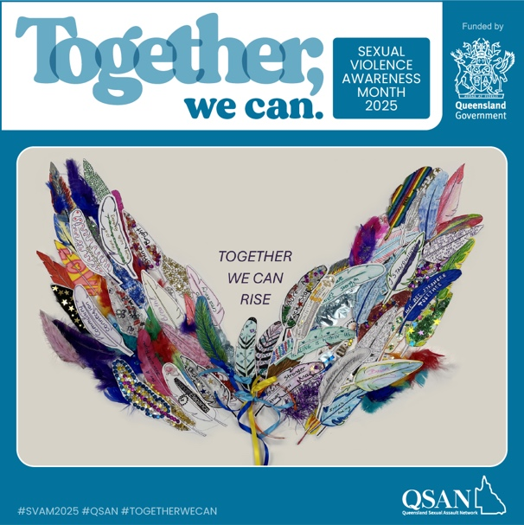
© Copyright retained by the artist.
Alternative text: A montage made of coloured and patterned feathers to form outstretched wings on either side of the words Together we can rise
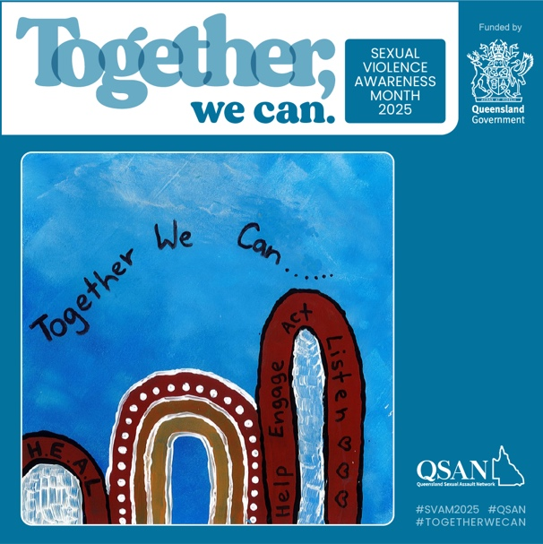
© Copyright retained by the artist.
Alternative text: On a blue background, painted arches in ochre, deep red and white with the words Together we can heal, help, engage, act listen.
Accompanying text:
TOGETHER, WE CAN.
October is Sexual Violence Awareness Month in Queensland.
As the month concludes, we focus on creating lasting change. Ending sexual violence requires a collective action: changing attitudes, supporting survivors and amplifying their voices. Together, we can drive real change to build communities where respect, safety and justice for all are non-negotiable.
If you wish to talk to someone about issues of sexual violence, please contact the national sexual violence helpline 1800 Respect 1800 737 732 (24/7) or contact a QSAN service at https://qsan.org.au/services/
In an emergency, phone the police on Triple Zero (000).
© Copyright retained by the artist.
This project is funded by the Queensland Government.
#SVAM2025 #TogetherWeCan #EndSexualViolence #SupportSurvivors #SexualViolenceAwareness #NoMore #SurvivorVoices

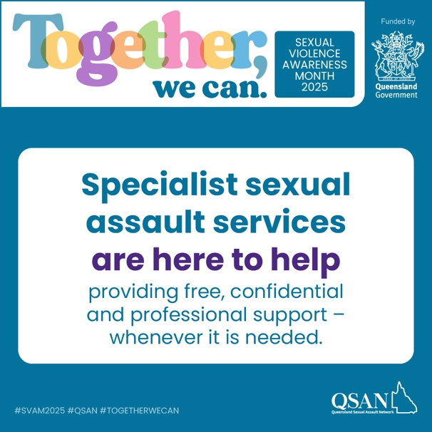
Alternative text: Text reads: Specialist sexual assault services are here to help providing free, confidential and professional support whenever it is needed.
Accompanying text:
WHAT IS A SPECIALIST SEXUAL SUPPORT SERVICE?
After experiencing sexual violence, it can feel daunting to know where to turn. Specialist sexual assault services provide a safe, supportive place to begin healing.
These inclusive and accessible services are free, confidential and led by trained professionals who understand the impacts of sexual violence.
They can offer:
🩵 Counselling and emotional support
🩵 Advocacy with health services, police or courts
🩵 Safe spaces to process experiences at your own pace
🩵 Information about rights and options
Specialist services work from a trauma-informed and empowerment-based approach. This means you are listened to, believed, and supported to make your own choices about what happens next.
No matter where you are in your journey, specialist sexual assault services are here to walk alongside you. If you wish to talk to someone about issues of sexual violence, please, you can find a directory of specialist sexual assault services at the QSAN Services Page here: http://bit.ly/41yv9jS
Alternatively, contact the national sexual violence helpline 1800 Respect 1800 737 732 (24/7).
In an emergency, phone the police on Triple Zero (000).
This project is funded by the Queensland Government.
#SVAM2025 #TogetherWeCan #RisingWithStrength #SurvivorVoices #SexualViolencePrevention #SupportSurvivors #NoMore

Week Five
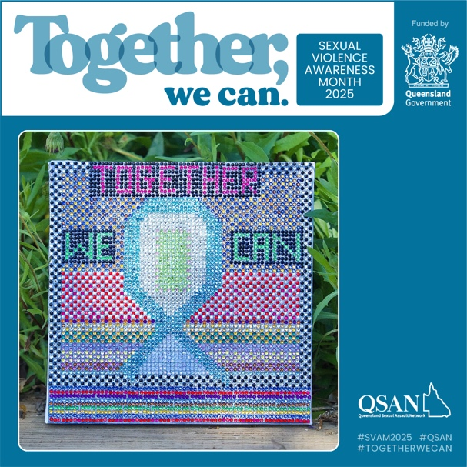
© Copyright retained by the artist.
Alternative text: A canvas covered in a grid of multicoloured sequins that depict a teal bow with the words Together we can.
Accompanying text:
TOGETHER, WE CAN.
October is Sexual Violence Awareness Month in Queensland.
As the month concludes, we focus on creating lasting change. Ending sexual violence requires a collective action: changing attitudes, supporting survivors and amplifying their voices. Together, we can drive real change to build communities where respect, safety and justice for all are non-negotiable.
If you wish to talk to someone about issues of sexual violence, please contact the national sexual violence helpline 1800 Respect 1800 737 732 (24/7) or contact a QSAN service at https://qsan.org.au/services/
In an emergency, phone the police on Triple Zero (000).
© Copyright retained by the artist.
This project is funded by the Queensland Government.
#SVAM2025 #TogetherWeCan #EndSexualViolence #SupportSurvivors #SexualViolenceAwareness #NoMore #SurvivorVoices

